
A PROJECT REPORT
on
DETECTION OF MALICIOUS BOTS
Submitted By
MEGHANA M
NB25MCA023
In Partial fulfilment of the requirements for the awards of the Degree
Master of Computer Applications
2025 - 26

Under the Guidance of
Dr. Vidya Sagar
Associate Professor, NMIT.
Department of MCA

Department of Master of Computer Application
Bengaluru-560064

LA2 Assignment Rubric - Advanced Operating Systems

Title of the Assignment: DETECTION OF MALICIOUS BOTS
Subject Name: Advance operating system
Subject Code: 25MCA106
Student Name : MEGHANA
USN(Register Number): NB25MCA023
Sem : 1st
Year : 2025-26

Criteria | Marks | Grading
1. Problem Understanding & Definition of the topic | 2
2. Design / Approach (with GitHub Proof) | 2
3. Implementation / Execution (Code Sample) | 2
4. Results & Analysis (Screens of Output) | 2
5. LA 2 report Presentation & Clarity | 2
Total | 10

Signature Of the Faculty

ABSTRACT
With the explosive growth of social media platforms, there has been a corresponding rise in the presence of automated accounts, or "bots", that interact with users and disseminate content. While some of these bots are benign and even useful, such as those providing weather updates or customer service, a significant and growing number are malicious in nature. Malicious social bots are designed to manipulate public discourse, spread misinformation, inflate follower counts, launch phishing attacks, and even influence political processes. Their activities threaten the authenticity of online communication, compromise user privacy, and can destabilize social trust. This project focuses on the detection of such malicious social bots, with a particular emphasis on identifying patterns and behaviors that differentiate them from genuine human users and non-malicious bots. The proposed system integrates multiple detection strategies, including natural language processing (NLP) for analyzing tweet content, statistical analysis of user metadata, and behavioral modeling of interaction patterns. Data is collected using APIs such as Tweepy, and features are extracted from timelines, retweet behavior, posting frequency, and follower/following ratios. Machine learning models—including decision trees, random forests, and deep neural networks—are trained and evaluated to classify accounts based on these features. Additionally, tools like Botometer may be used to enhance detection accuracy by comparing known bot profiles. The system is designed to be scalable and adaptable to different types of bots as they evolve. Ultimately, the project aims to contribute to safer and more trustworthy social media environments by equipping platforms and researchers with tools to proactively identify and curb the influence of malicious social bots.

Architecture of the Program
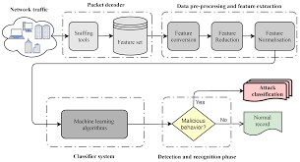
The diagram illustrates the complete workflow of a machine-learning-based network intrusion detection system. Network traffic is first captured from various devices using sniffing tools, and the captured packets are stored as a feature set. These raw features then pass through a data pre-processing and feature extraction stage, where they undergo feature conversion, feature reduction, and feature normalization to prepare the data for analysis. The processed features are then fed into a machine learning classifier system, which has been trained to identify abnormal patterns in network behavior. During the detection and recognition phase, the classifier analyzes incoming traffic and determines whether the behavior is malicious or normal. If malicious activity is detected, the system categorizes it under attack classification; otherwise, it is labeled as normal traffic. This pipeline enables automated, efficient, and accurate identification of malicious network behavior using machine learning.
Screenshots
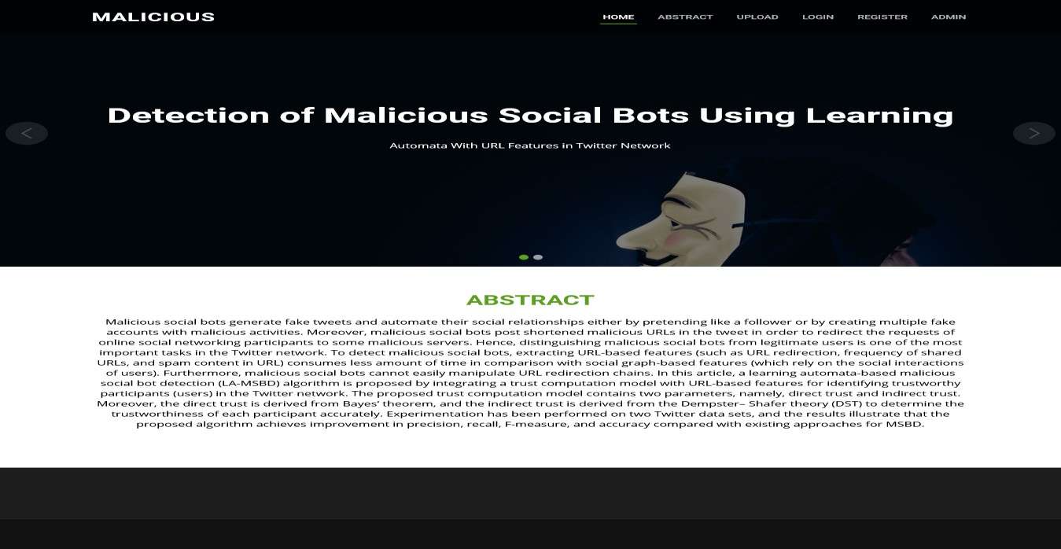

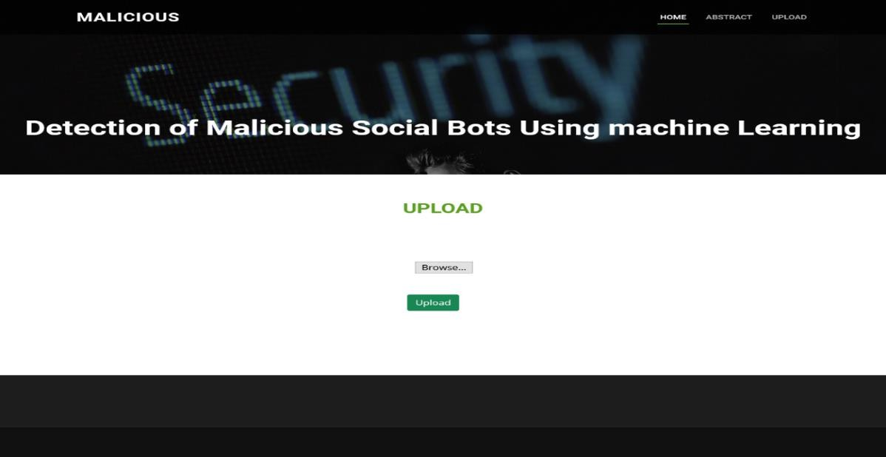

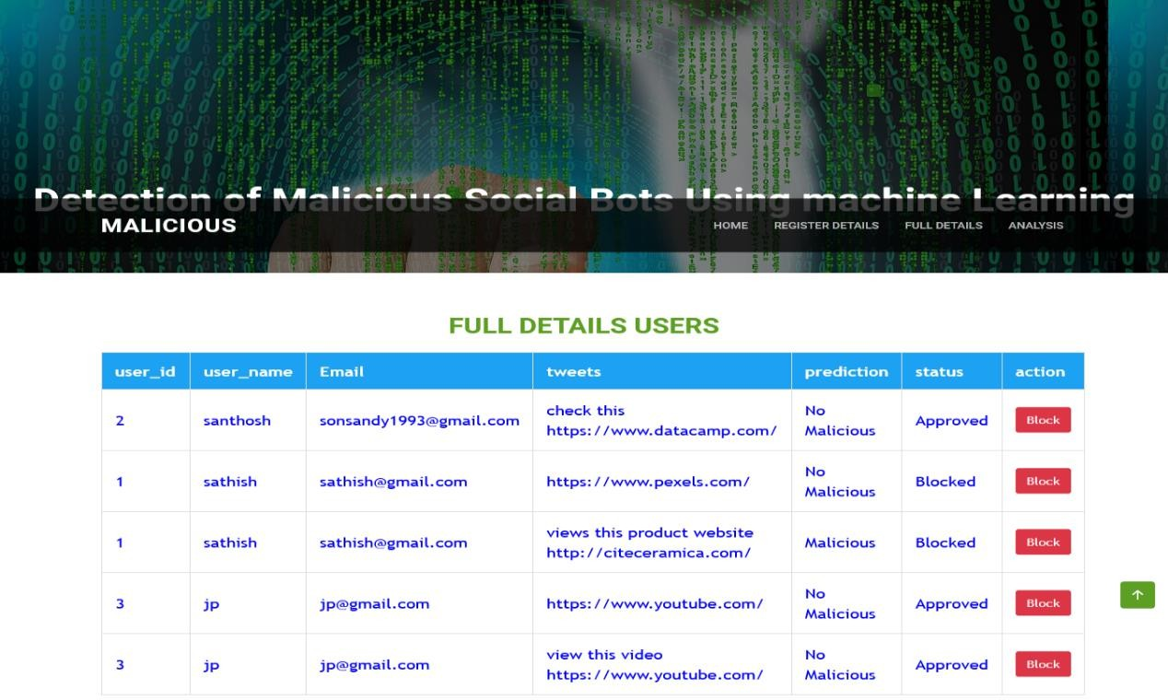

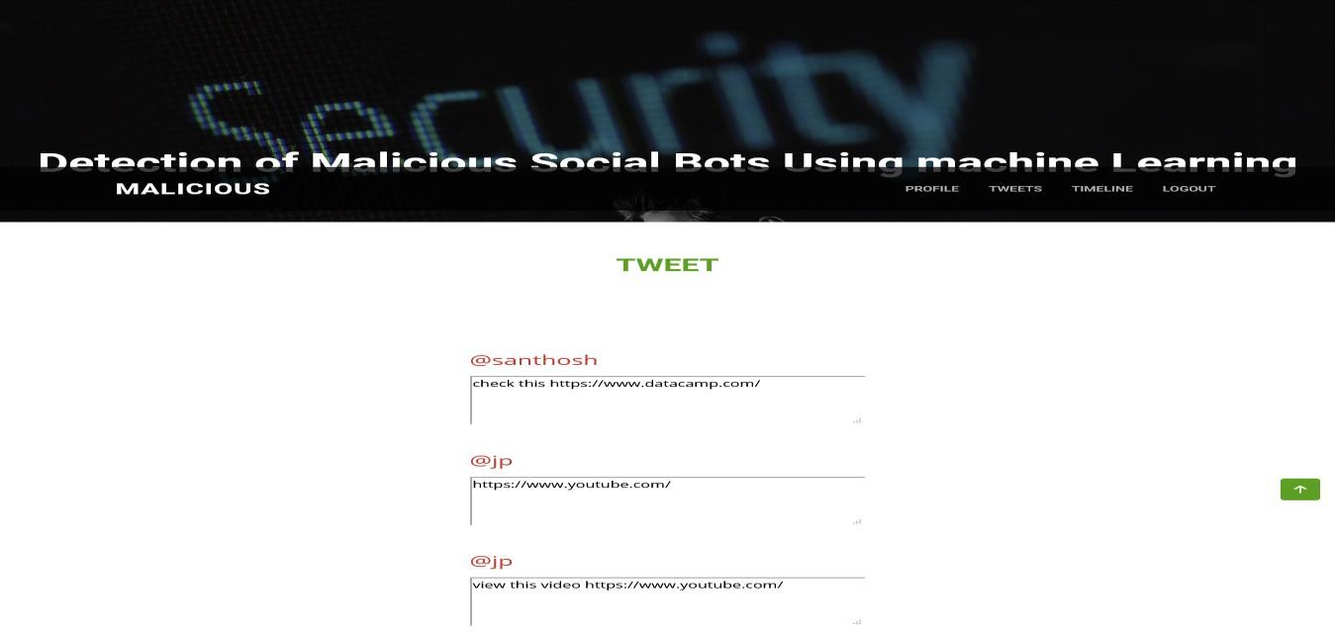

C0NCLUSION
This article presents an LA-MSBD algorithm by integrating a trust computational model with a set of URL-based features for MSBD. In addition, we evaluate the trustworthiness of tweets (posted by each participant) by using the Bayesian learning and DST. Moreover, the proposed LA-MSBD algorithm executes a finite set of learning actions to update action probability value (i.e., probability of a participant posting malicious URLs in the tweets). The proposed LA-MSBD algorithm achieves the advantages of incremental learning. Two Twitter data sets are used to evaluate the performance of our proposed LA-MSBD algorithm. The experimental results show that the proposed LA-MSBD algorithm achieves up to 7% improvement of accuracy compared with other existing algorithms. For The Fake Project and Social Honeypot data sets, the proposed LA-MSBD algorithm has achieved precisions of 95.37% and 91.77% for MSBD, respectively. Furthermore, as a future research challenge, we would like to investigate the dependence among the features and its impact on MSBD.

